**BASIC FIREWALL CONFIGURATION (OPENING A PORT TO ALLOW TRAFFIC)**

**Objective:** Configure Windows Firewall to open a port (ex: TCP/5555) and test it.

To check If a specific port is open/close on Windows, Type the following command in the command prompt:

“Test-NetConnection -Port 5555 -ComputerName localhost”

This command gives the following result,

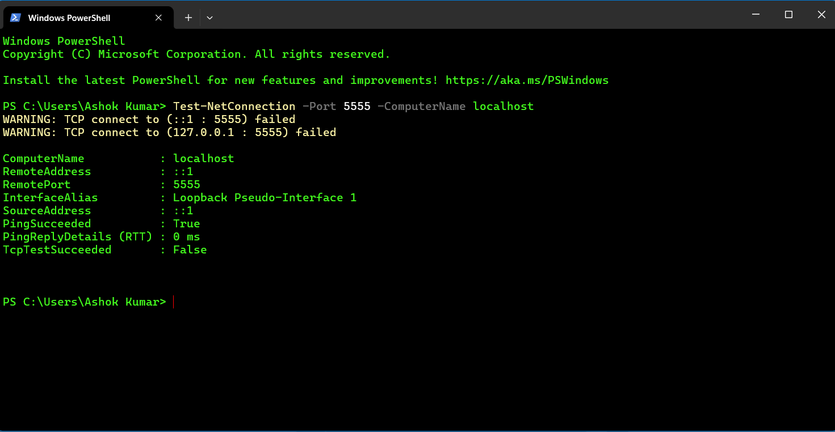

The image above shows that the port 5555 is closed.

“TCP connect to (127.0.0.1 : 5555) failed”

“TcpTestSucceeded : False”

After checking this we can now open this port to allow traffic through it by following the steps below.

**Step 1:** Open Windows Defender Firewall with Advanced Security. On the left-hand side select “Inbound rules” and on the right side of the screen click on “New rule”.

The window looks like this,

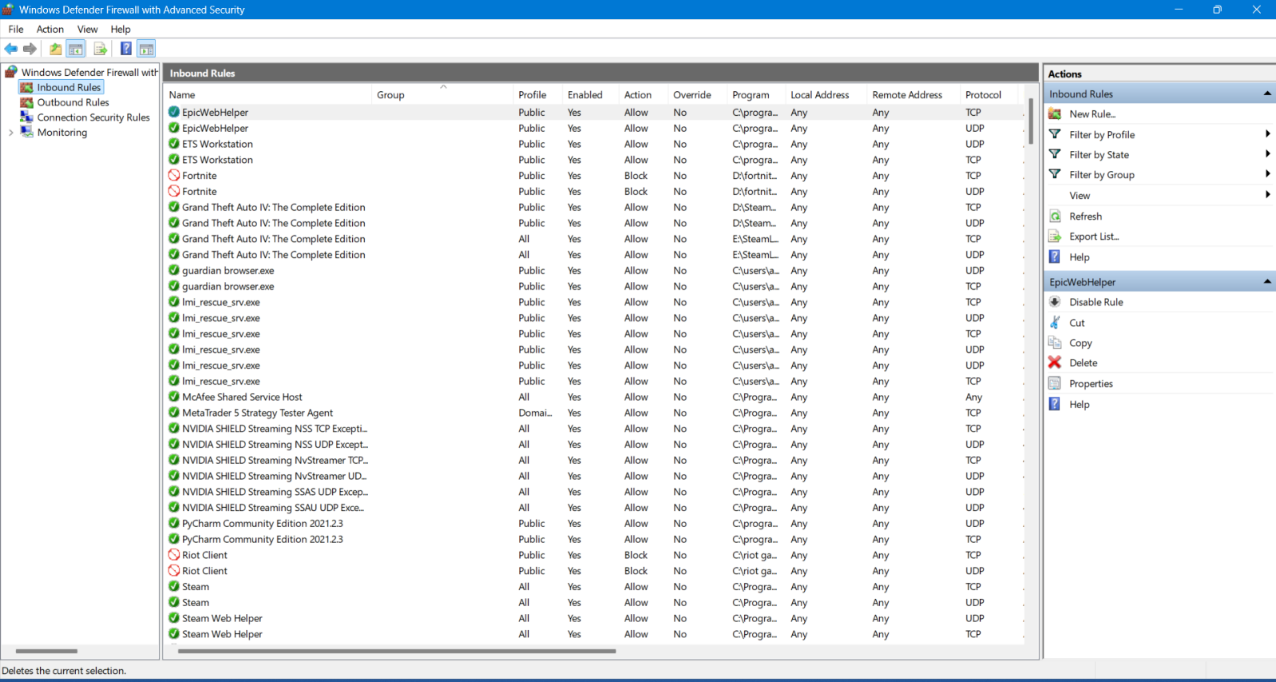

**Step 2:** After clicking on the new rule, a new window opens named “New Inbound Rule Wizard”

Under that select the “port” option and click on next.

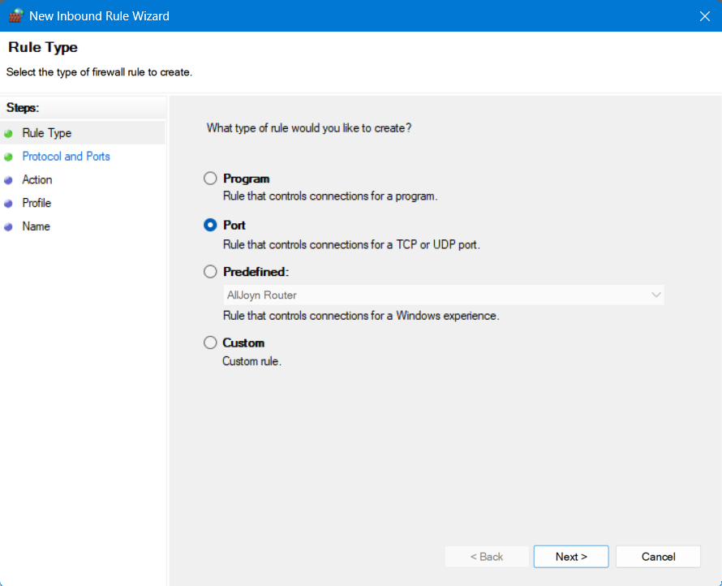

**Step 3**: After clicking on next , select the type of port which in this case is TCP and enter the value

“5555” under “Specific local ports: “ and click on next.

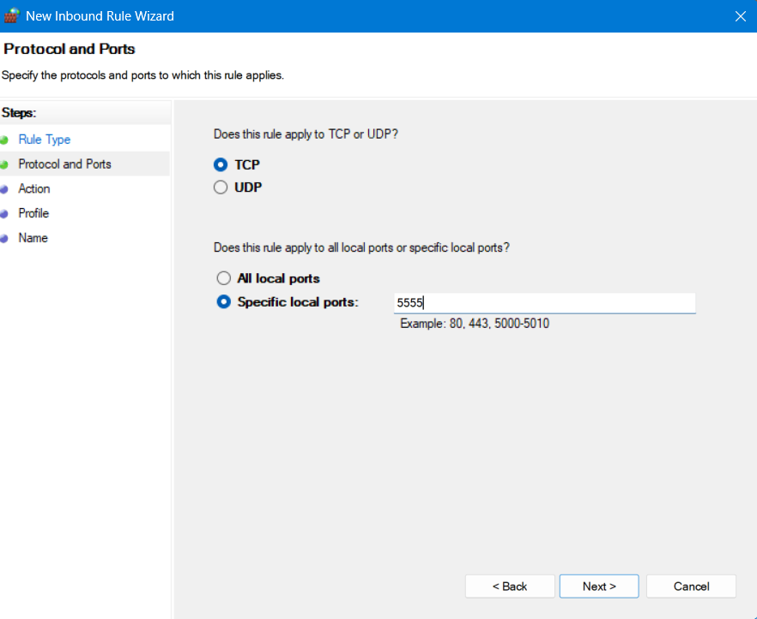

**Step 4:** After clicking on next, it askes for “What action should be taken when a connection matches the specified conditions?” Under that we are going to select “Allow the connection” as shown in the image below and click on next.

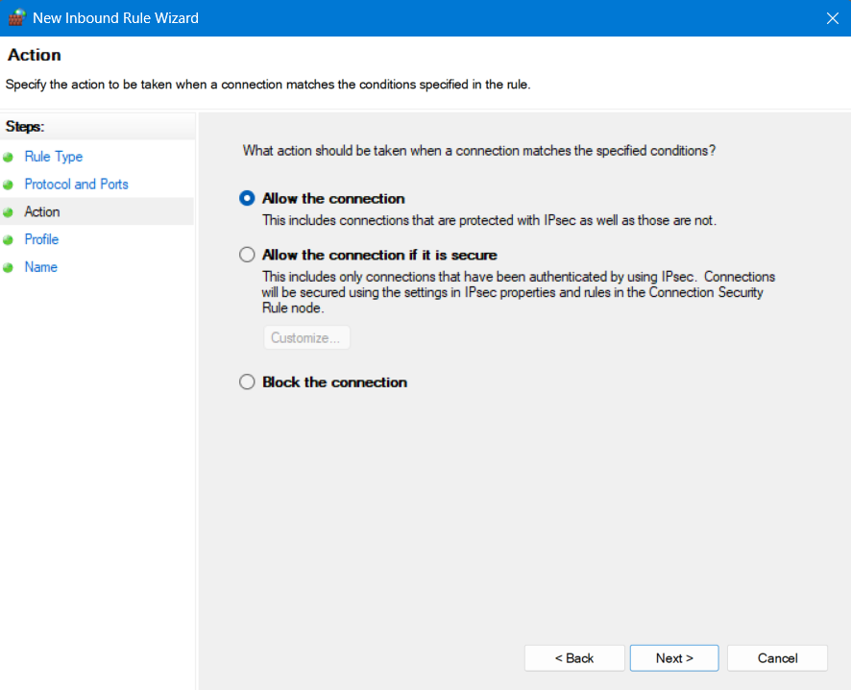

**Step 5:** After clicking on next, We need to select when does the rule apply. Here we are going to tick the check boxes of “Private” and “Public” as shown in the picture below and then click on next.

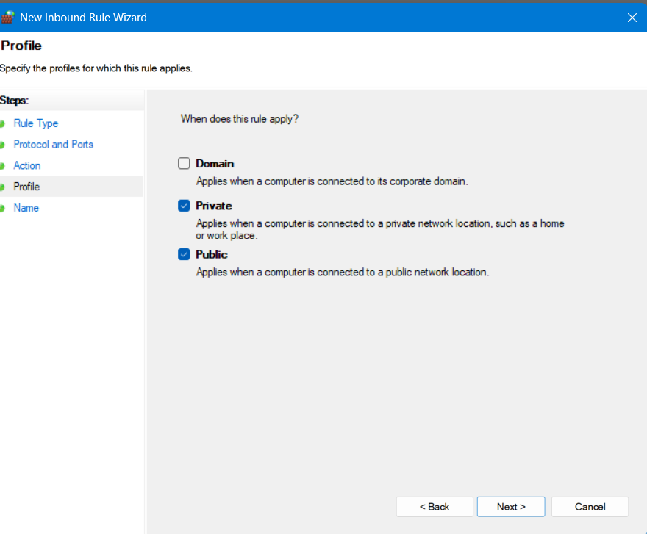

**Step 6:** After the previous step now just need to give a name and discription for our configuration. Here I gave the name “Port 5555_test” and I left the description empty.

We can check in the main menu of the Windows Defender is our port was allowed like shown in the image below

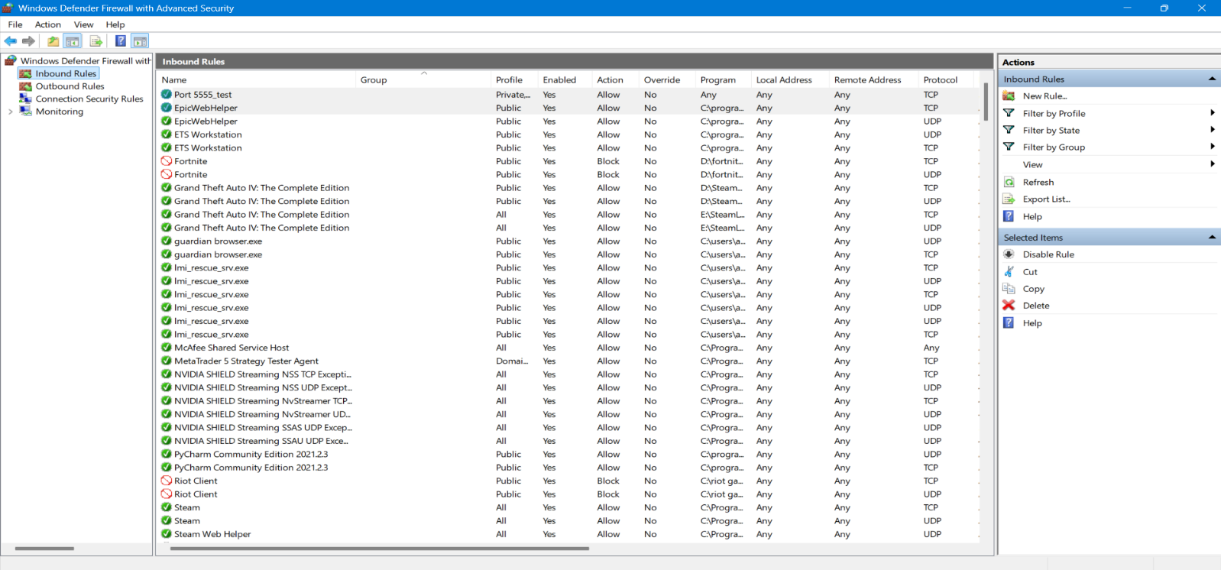

**Step 7:** All the steps are done to allow the TCP/5555 port on your system using the Windows Defender in just a few steps. Now we just need to check if our operation was succesfull.

To do this we need to run the same command we ran in the beginning to check if that port is running or closed. But before we do that we need to set up a listener on cmd using netcat so that the port will be actively listening or else even after being open it will not show up in the scan.

To use netcat you need to download it for windows first. You can refer google to download it yourself.

After that we just nee to run the command below to set up a listener on port 5555:  
 “ncat -lvp 5555”

The image below shows how it works

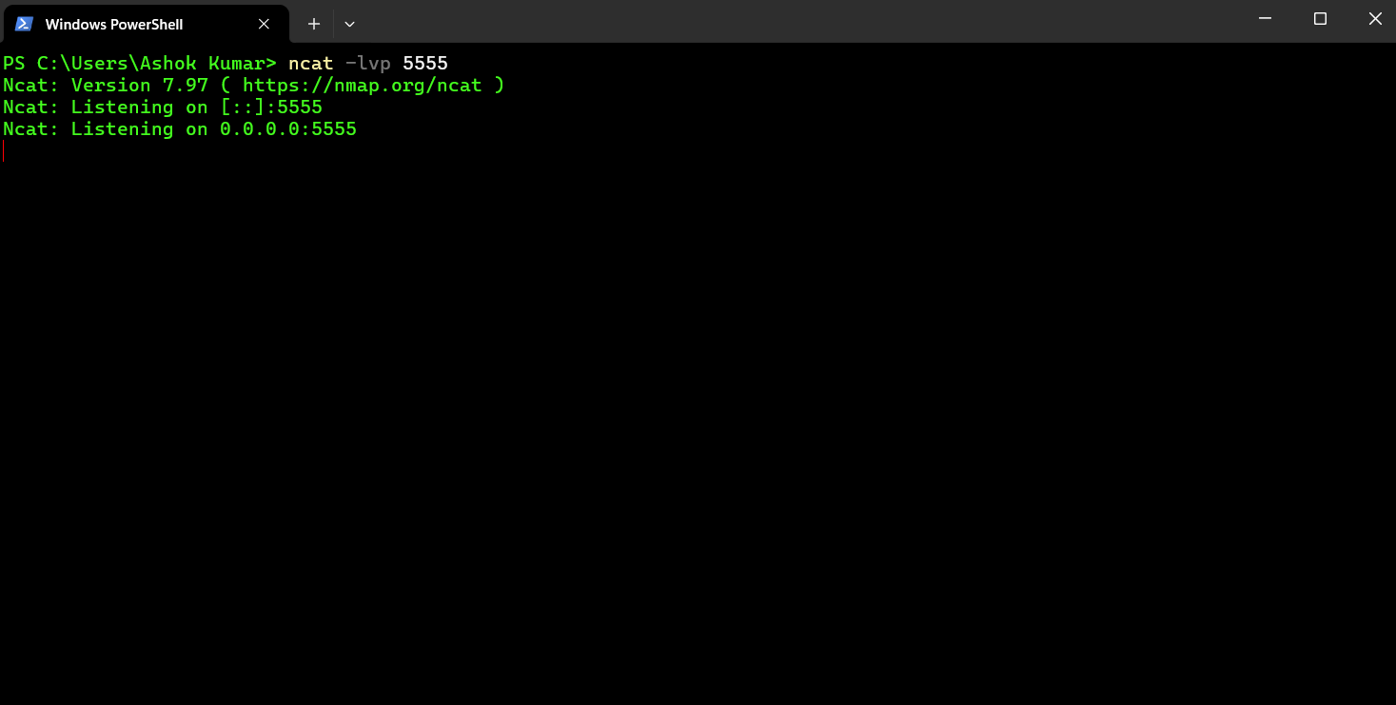

**Step 8:** Now we have set up our listener succesfully and now we just need to verify this by using the same command we used earlier.

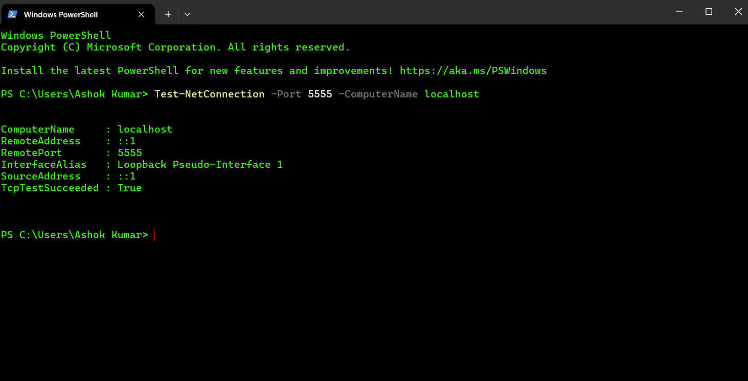

**Result:** Here we can see that the TCP/5555 port is now open. This verifies that our Windows Defender configuration to allow TCP port 5555 is successful.